Need a little help writing a bio for your Star?

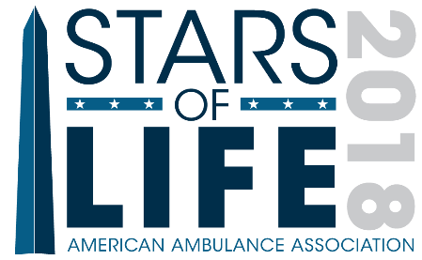 | - Read a few examples from the 2017 Stars Program book, then use the examples below to get off on the right track. These are not intended as rigid templates, but rather as an aid, if helpful, when pulling together your Star’s bio.  - The ideal bio is about one-third to two-thirds of a page in length.  - Have questions? Email info@ambulance.org

Openers
A few sample opening sentences below to help the reader understand the basics about your Star.
- Jane Smith has served ABC Ambulance as a Field Training Officer for more than eight years. During this time, she has made a name for herself as the go-to mentor for new employees learning the ropes. She makes everyone feel welcome from the moment they join the team.
- Joe Smith joined XYZ Ambulance as an EMT three years ago, and has since attained the status of Paramedic. During this time, he has proven himself to be a deeply compassionate caregiver for our patients, as well as a true team player. He is always ready to help at a moment’s notice.
- Jack Smith was selected as 123 Ambulance’s 2018 Star of Life because of his selfless service to a patient in need. Jack, a Paramedic with 123 for more than 30 years, has always demonstrated top-notch clinical skills. On August 14, 2017, however, they were truly put to the test.

Show Your Star’s Impact / Tell a Story
Here is where you give examples that demonstrate just what your Star. Is there an example project, patient compliment, performance evaluation, or extraordinary call that showcases his or her talents?
- Jane spearheaded an effort to redesign our new hire training process that has helped our recruits learn the ropes more quickly while reducing new employee turnover. She worked with her fellow FTOs to gather data…
- Joe is known by all for his smile and his positive outlook. We recently received a complimentary note from the daughter of a woman he cared for several times, stating that, “My mother always mentioned to me how kind and helpful EMS was during her most stressful days.” …
- While on an overnight shift in Anytown, Jack and his partner, Abraham Lincoln, were first to respond to a multi-vehicle collision on the interstate. Jack and Abe leapt into action, and …

Get (A Little) Personal
Share a bit about your Star’s family, interests, and talents OUTSIDE of EMS.
- When not providing excellent prehospital care to the people MyTown, Jane enjoys spending time with her husband, John, and children, Sarah and Michael. She also volunteers as a literacy teacher at the community library.
- Joe’s team spirit carries over into his home life. He is co-captain of his team, The Tigers, in the Anytown recreational soccer league. His wedding to his fiancé, Amy, is set for Spring 2019.
- Jack was born and raised in Anytown, and graduated from OSU in 2000 with a degree in underwater basket weaving. On weekends, he enjoys scouring local garage sales for vintage milk pails as well as taking salsa classes with his friends.

Pull It All Together
Close with a line that wraps up the whole bio.
- ABC Ambulance is proud to call Jane Smith our 2018 Star of Life!
- Thank you, Joe Smith, for all that you do to support XYZ Ambulance and the communities we serve.
- The people of MyTown thank you, Jack Smith, for your selfless service.

